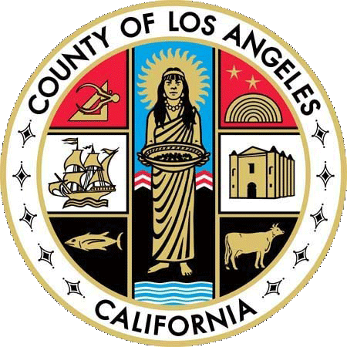 County of Los Angeles 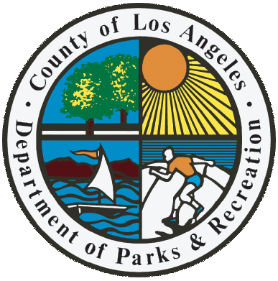
Department of Parks and Recreation

William S. Hart Park

Present

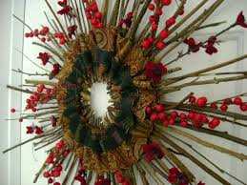

6th Annual Hart Holiday
Boutique & Craft Fair

November 25^{th &} 26th, 2017 – 10am to 4pm – Hart Hall

Artisans & Vendors Offer Great and Unique Holiday Gift
Items For Sale
Admission is free

William S. Hart Park – 24151 Newhall Ave, Newhall, Ca 91321

For information: 259-1750 or Email: aewing@parks.lacounty.gov
ADA Notice

Pursuant to the Americans with Disabilities Act (ADA), the County of Los Angeles, Department of Parks and Recreation, has designated an ADA Coordinator to
carry out this Department’s compliance with the non-discriminatory provisions of the ADA. For more information you may contact the ADA Coordinator’s Office
at TEL (213) 738-2970, TDY (213)427-6118, FAX (213)487-0380; upon 3-day request notice, sign language interpreters and related materials in alternate formats
(Braille-transcript, large print, audio-recording, video-captioning, live-description) or any other reasonable accommodations are available to the public for County-
sponsored activities and events.

